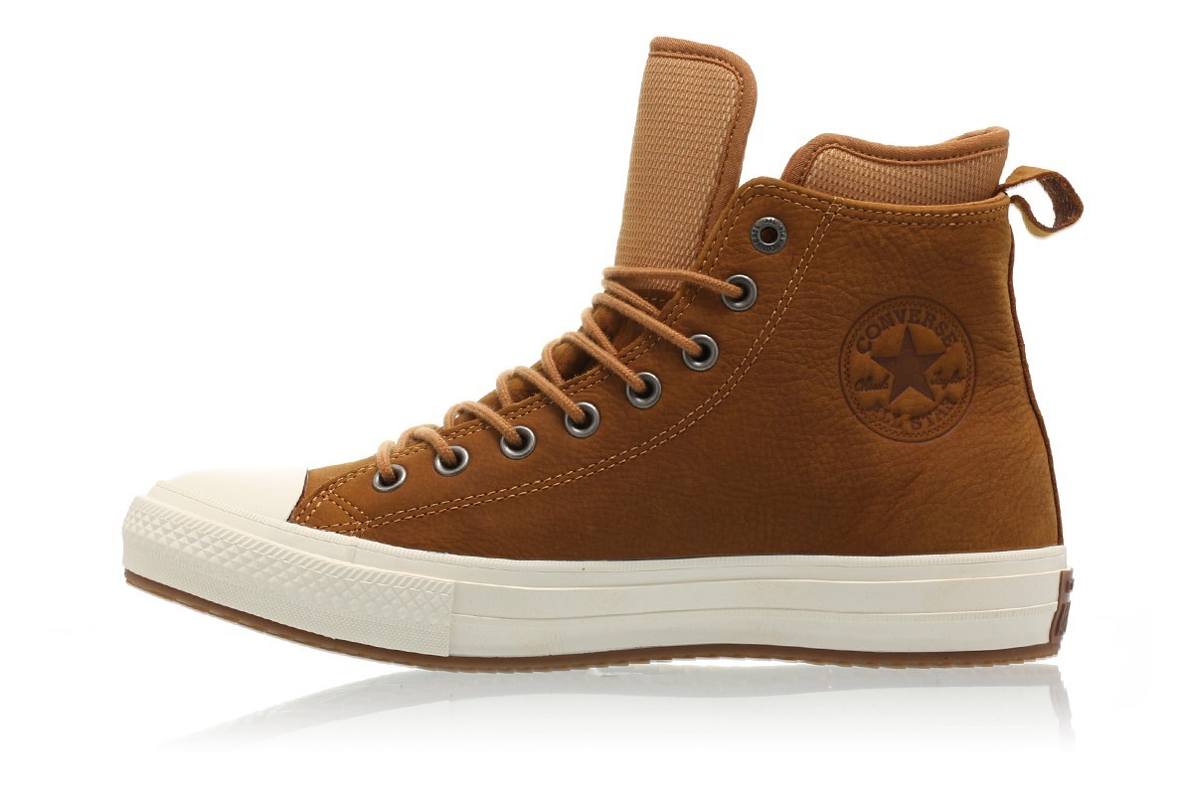

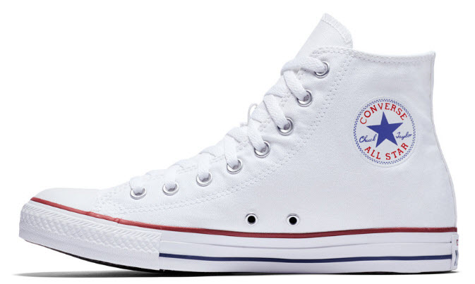

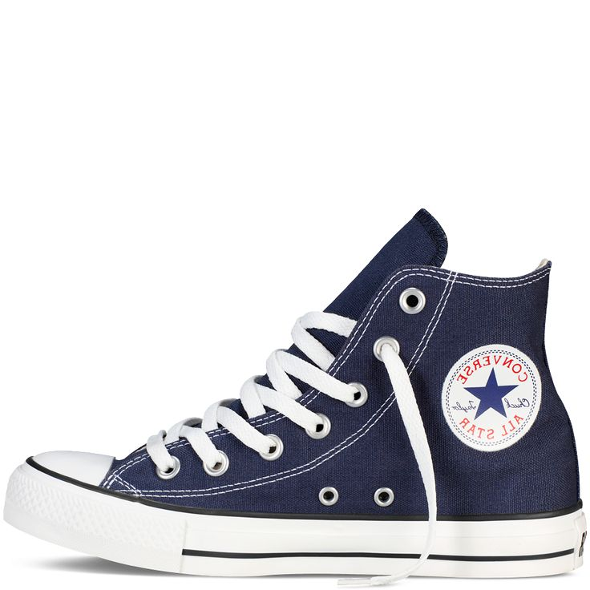

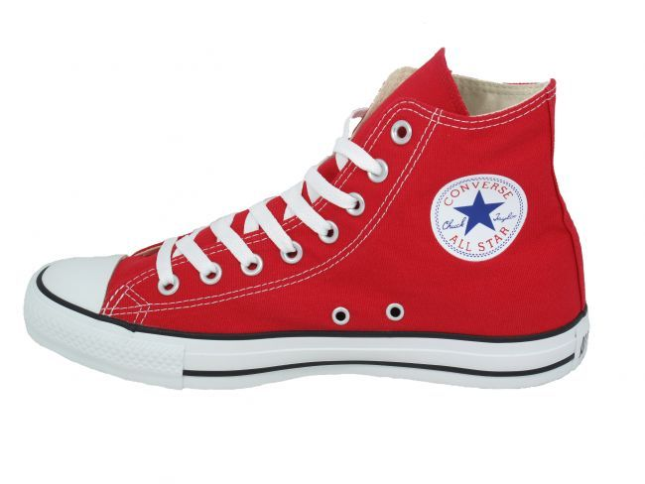

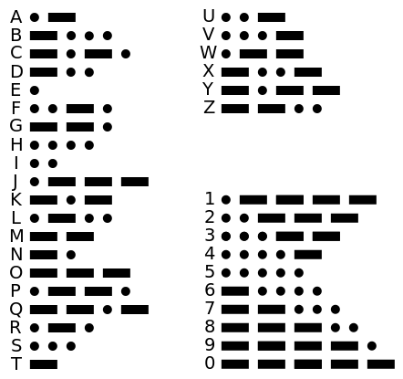

|  |  |  |
| --- | --- | --- |
| Image result for spiderman | Image result for toy dinosaurs | Image result for lego |
| Image result for Candy | Related image | Image result for teddy bear |
| Image result for toy car | Image result for dice | Image result for toy train |

|  |  |  |
| --- | --- | --- |
|  |  |  |

|  |
| --- |
| Image result for mac computer |
| Image result for puppet show stage |
| https://res.westwind.ab.ca/uploads/1263/756ph.jpeg |

|  |
| --- |
|  |
|  |
|  |

